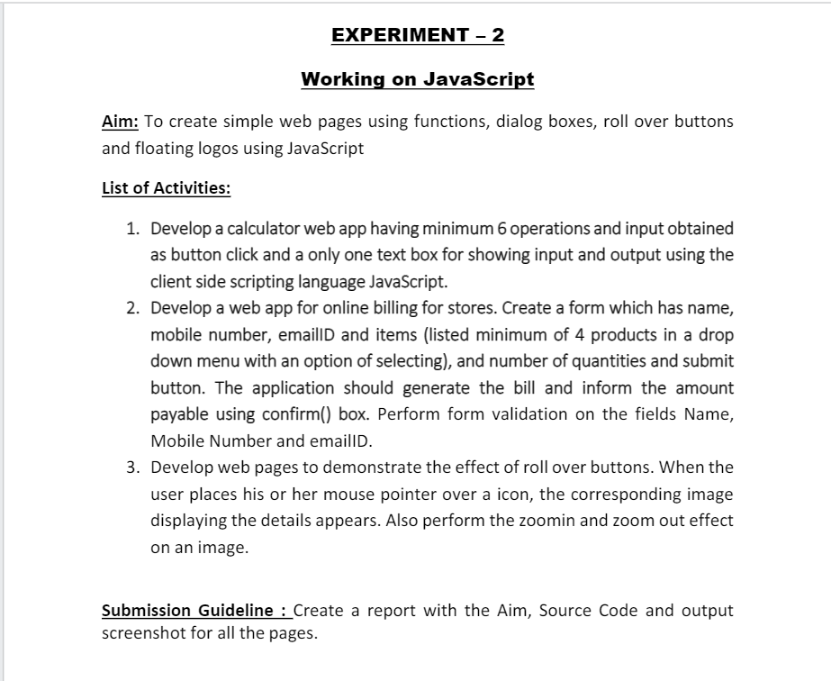

**Answer :1**

**Coding:**

Html Code**:**

<!DOCTYPE html>

<html >

<head>

  <title>Calculator using HTML, CSS and JavaScript</title>

  <link rel="stylesheet" href="cal.css">

</head>

<body>

    <h1>

        <font color="black", size="10">

            <center>

                Calculator

            </center>

        </font>

    </h1>

<table class="calculator" >

  <tr>

    <td colspan="3"> <input class="display-box" type="text" id="result" disabled /> </td>

    <td> <input type="button" value="C" onclick="clearScreen()" id="btn" /> </td>

  </tr>

  <tr>

    <td> <input type="button" value="1" onclick="display('1')" /> </td>

    <td> <input type="button" value="2" onclick="display('2')" /> </td>

    <td> <input type="button" value="3" onclick="display('3')" /> </td>

    <td> <input type="button" value="/" onclick="display('/')" /> </td>

  </tr>

  <tr>

    <td> <input type="button" value="4" onclick="display('4')" /> </td>

    <td> <input type="button" value="5" onclick="display('5')" /> </td>

    <td> <input type="button" value="6" onclick="display('6')" /> </td>

    <td> <input type="button" value="-" onclick="display('-')" /> </td>

  </tr>

  <tr>

    <td> <input type="button" value="7" onclick="display('7')" /> </td>

    <td> <input type="button" value="8" onclick="display('8')" /> </td>

    <td> <input type="button" value="9" onclick="display('9')" /> </td>

    <td> <input type="button" value="+" onclick="display('+')" /> </td>

  </tr>

  <tr>

    <td> <input type="button" value="." onclick="display('.')" /> </td>

    <td> <input type="button" value="0" onclick="display('0')" /> </td>

    <td> <input type="button" value="=" onclick="calculate()" id="btn" /> </td>

    <td> <input type="button" value="*" onclick="display('*')" /> </td>

  </tr>

</table>

<script type="text/javascript" src="fun.js"></script>

</body>

</html>

Css Code:

.calculator {

    padding: 15px;

    border-radius: 15px;

    border: solid black 1px;

    height: 500px;

    width: 500px;

    margin: auto;

    background-color: aqua;

}

.display-box {

    background-color: blue;

    border: solid black 2px;

    color: black;

    border-radius: 10px;

    width: 98%;

    height: 70%;

}

input[type=button]

{

    font-family: 'Orbitron', sans-serif;

    background-image: linear-gradient(#544449, #242123);

    color: rgb(254, 251, 251);

    border: solid rgb(16, 15, 15) 1.5px;

    width: 100%;

    border-radius: 100%;

    height: 80%;

}

JS Code:

function clearScreen() {

    document.getElementById("result").value = "";

}

function display(value) {

    document.getElementById("result").value += value;

}

function calculate() {

    var p = document.getElementById("result").value;

    var q = eval(p);

    document.getElementById("result").value = q;

}

**Output Screenshot:**

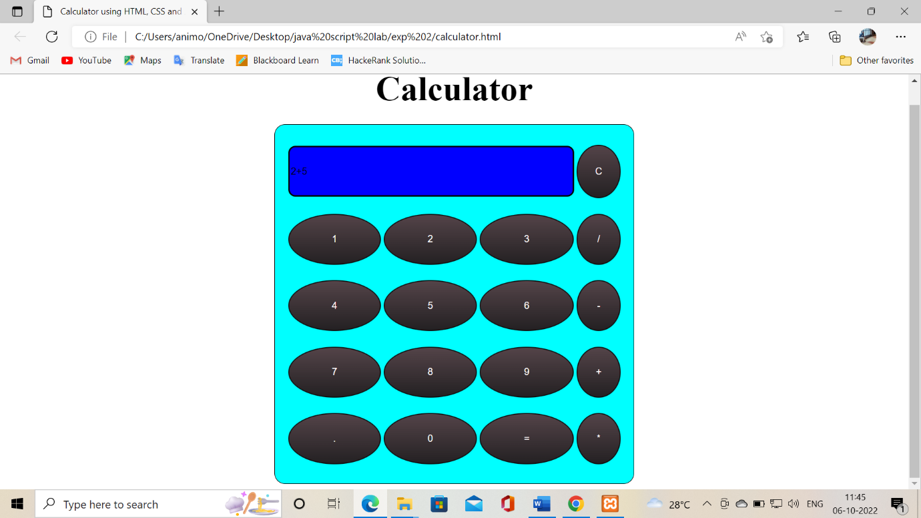

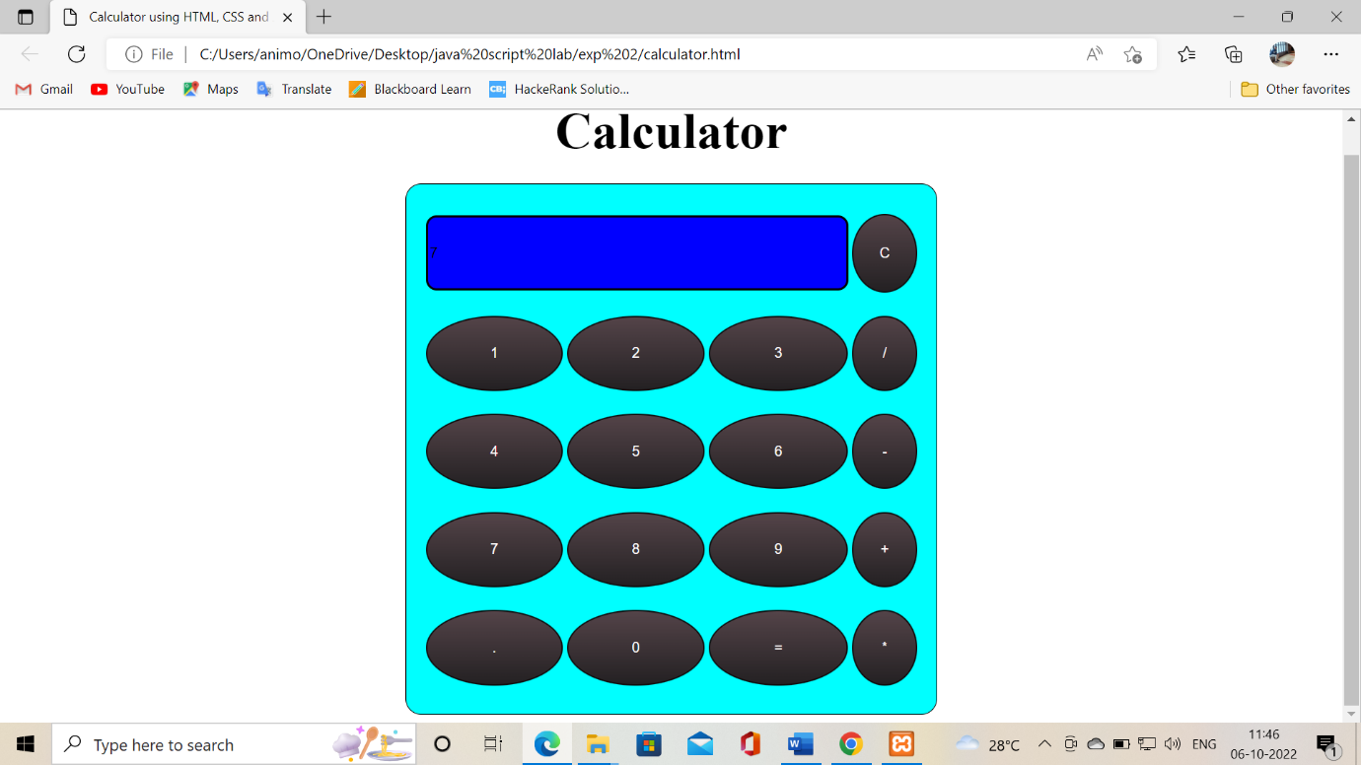

**Answer :2**

**Coding:**

Html Code**:**

<!DOCTYPE html>

<html lang="en">

<head>

    <meta charset="UTF-8">

    <meta http-equiv="X-UA-Compatible" content="IE=edge">

    <meta name="viewport" content="width=device-width, initial-scale=1.0">

    <link rel="stylesheet" href="billing.css">

    <script type="text/javascript" src="billing.js"></script>

    <title>Document</title>

</head>

<body>

    <div class="container">

        <div class="card">

            <form action="#">

                <label for="name">Enter Your Name : </label>

                <input type="text" id="name" onblur="checkName()">

                <label for="number">Enter Your Mobile Number : </label>

                <input type="text" id="number" maxlength="10" onblur="checkNumber()">

                <label for="email">Enter Your Email</label>

                <input type="email" id="email" onblur="checkEmail()">

                <label for="list">Choose a Product : </label>

                <select name="list" id="product">

                    <option>Pencil</option>

                    <option>Pen</option>

                    <option>Register</option>

                    <option>Eraser</option>

                </select>

                <label for="list">Enter the Amount : </label>

                <input type="text" id="amt">

                <input type="button" class="submit" value="submit" onclick="getResult()">

            </form>

        </div>

    </div>

</body>

</html>

Css Code:

* {

    margin: auto;

}

.card {

    width: 37rem;

    box-shadow: rgba(99, 99, 99, 0.2) 0px 2px 8px 0px;

    margin-top: 3rem;

    border-radius: 5px;

    padding: 1rem;

}

form {

    display: flex;

    height: 45rem;

    width: 26rem;

    justify-content: space-around;

    flex-direction: column;

}

input {

    width: 25rem;

    border: none;

    height: 2rem;

    outline: none;

    border-bottom: 1px solid #4e4949;

    transition: 0.5s ease;

}

input[type=submit] {

    border: none;

}

label {

    width: 25.4rem;

    font-size: 1.2rem;

}

select {

    width: 25rem;

    height: 2rem;

}

JS Code:

function checkName() {

    var strName = document.getElementById("name").value;

    empty(strName,"name");

}

function checkNumber() {

    var strNumber = document.getElementById("number").value;

    if(strNumber == "") {

        document.getElementById("number").style.borderBottom="#c91b1bba solid 3px";

    }

    else {

        if(isNaN(strNumber)) {

            document.getElementById("number").style.borderBottom="#c91b1bba solid 3px";

        }

        else {

            document.getElementById("number").style.borderBottom="1px solid #4e4949";

        }

    }

}

function checkEmail() {

    var strEmail = document.getElementById("email").value;

    empty(strEmail,"email");

}

function getResult() {

    var price

    var productName = document.getElementById("product").value;

    if(productName == "Pen"){

        price = 2

    }

    else if(productName == "Pencil"){

        price = 5

    }

    else if(productName == "Register"){

        price = 20

    }

    else {

        price = 3

    }

    var amt = parseInt(document.getElementById("amt").value);

    totalPrice = amt * price;

    alert(totalPrice);

}

**Output Screenshot:**

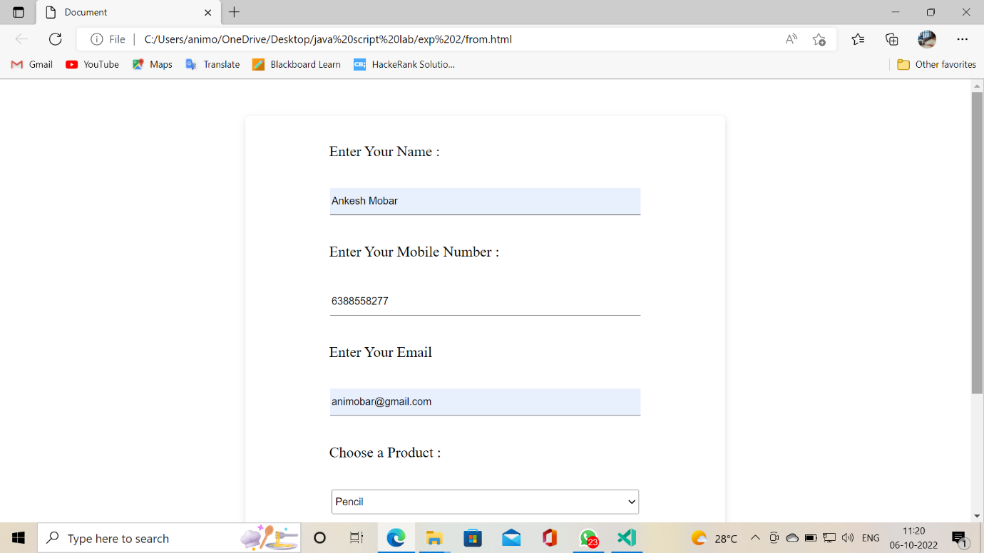

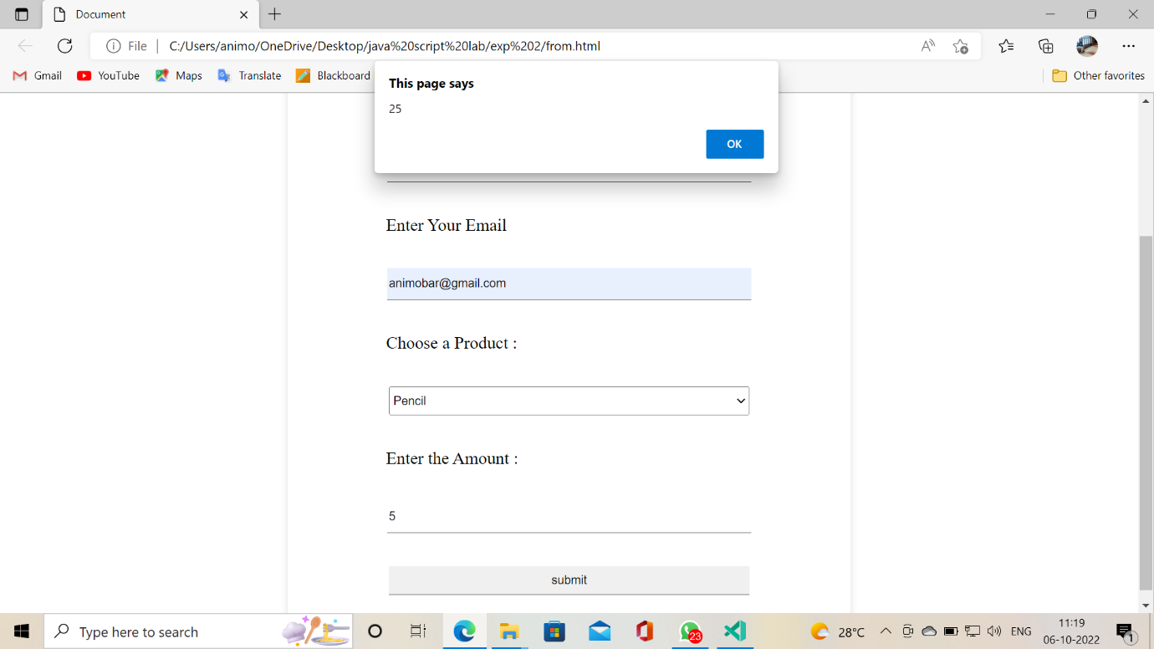

**Answer :3**

**Coding:**

Html Code**:**

<!DOCTYPE html>

<head>

<meta charset="UTF-8"/>

<title>"Roll over button"</title>

<style>

.zoom{

padding: 100px;

transition: transform .5s;

width: 400px;

height: 300px;

margin: 0 auto;

}

.zoom:hover{

transform: scale(1.5);

}

.body{

    overflow: hidden;

}

</style>

</head>

<body>

<div class="zoom">

<img src="apple.jpg" alt="image" title="This is an apple" width="300px" height="200px">

</div>

</body>

</html>

**Output Screenshot:**

